CAEN International Summer School 2026
Activity Report
23 / 07 / 2026

Name: | Antonio Messina | University / Country: | INFN

. Title
Making a firmware that implement a Pulse Shape Discrimination (PSD) on the CAEN SCDIK board, using Sci-Compiler.

. Abstract
During the practical session, we developed a Pulse Shape Discrimination (PSD) using Sci-Compiler. This technique uses the ratio between the peak amplitude and the integrated charge (peak/Qshort). Test signals were made with a digital detector emulator (CAEN DT5810). This device let us produce two artificial populations of pulses with different waveforms: one like "neutron" events (slow) and another population like "gamma" events (fast. We collected data for 2000 buffer read cycles, with a trigger threshold of 45 ADC counts, and got more than one million events. We analyzed the data offline in Python, making the energy spectrum and the PSD vs Energy plot. This last plot shows two bands very well separated, that match with the two artificial populations we made. This shows that the algorithm works well.

1.. Purpose of the Experiment
The purpose of this experiment is to make, with the Sci-Compiler graphic tool, a Pulse Shape Discrimination. This technique uses the ratio between the area (integrated charge) and the peak amplitude of the pulse. Even if it is the simplest technique, it is the most used one, because it works in almost all real applications. The firmware chain has: a Trigger Derivative block that makes the derivative of the signal for the trigger, a Baseline Restorer, a separate chain to find the peak amplitude, a Delay Programmable block for time alignment, and two independent QDC blocks (one for a short integration = Qshort, one for a long integration = Qenergy). This to measure the total energy in a better way and have a better results The outputs go into a Wire Merge and then into a List block, which makes the final list of events. (Figure 1.)
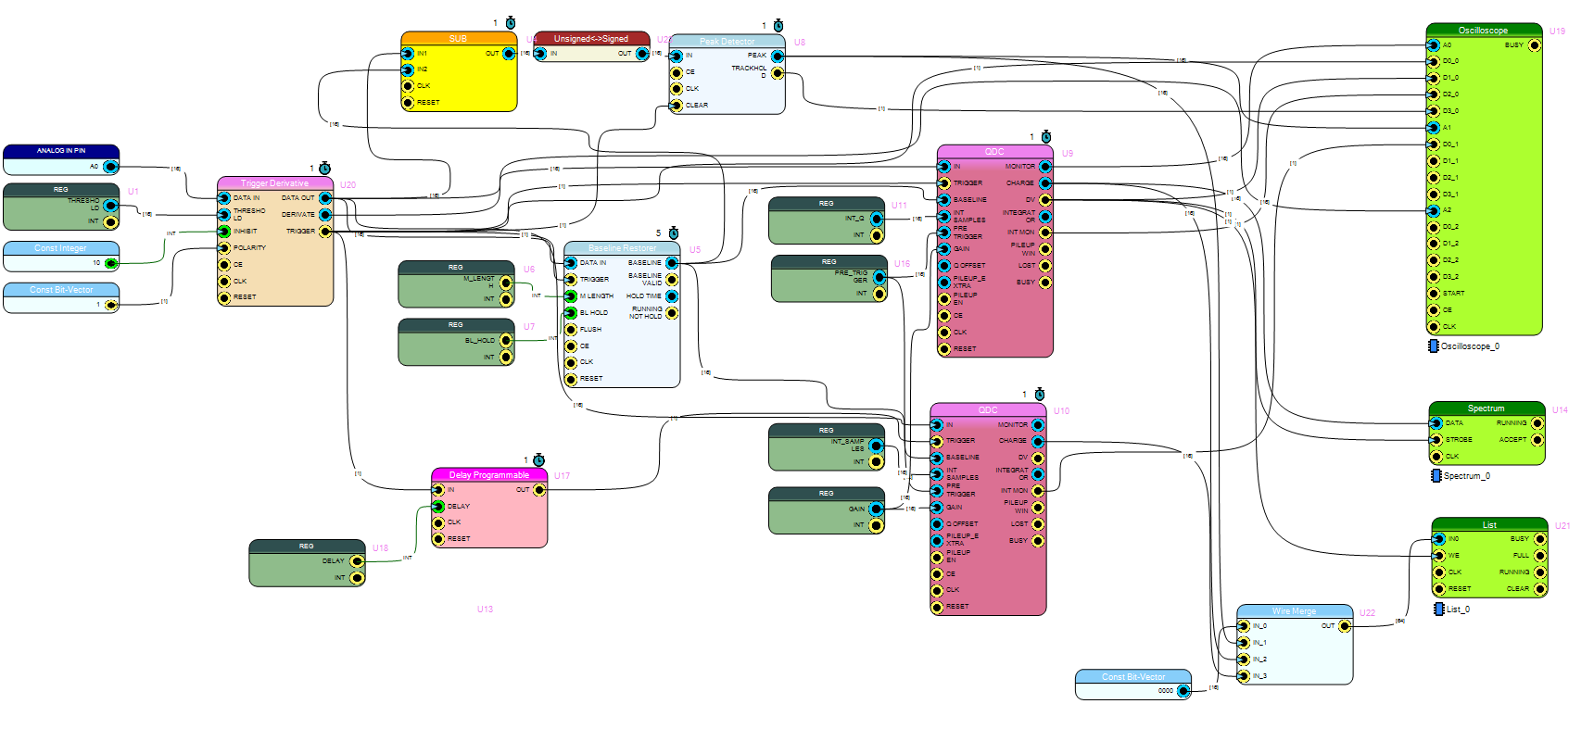
Figure 1: Block diagram of the firmware for the PSD for the CAEN DT1260 digitizer.
The input signal is made artificially with the Shape Generator, using exponential shapes with different decay constants (Tau) and mixing them with different probabilities, to look like gamma and neutron events. We expect that the PSD vs Energy plot will show two populations well separated. This separation is the way to check if the exercise was successful.

2.. Material
- CAEN DT1260 digitizer.
- CAEN DT5810 Fast Digital Detector Emulator.
- Sci-Compiler graphic environment, v. 2026.4.17.1 used to design and compile the FPGA firmware.
- Control PC with Python acquisition software and data analysis environment.
- Lemo Cable

3.. Measurements
The firmware chain was configured with these register parameters: THRESHOLD = 45, M_LENGTH = 8, BL_HOLD = 700, INT_Q = 300, GAIN = 500, INT_SAMPLES = 20, PRE_TRIGGER = 15, DELAY = 20. The input signal was using Exponential shapes with parameters Offset, Length, Amplitude and Tau (one example we saw: Offset 100 sample / 0.1 µs, Length 1000 sample / 1 µs, Amplitude 32767 LSB / 3.9178 V, Tau 1 µs). For every synthetic pulse, the two QDC blocks compute Qshort and Qenergy, and the Sub/Peak Detector chain finds the peak value. The Wire Merge block puts these three values together, and the List block makes one data packet for each event. From this data we get the energy (Qenergy) and the discrimination parameter PSD = peak / Qshort. I did 2000 cycles of buffer reading (blocking mode, timeout 500 ms). The data was saved in csv file and then loaded again to make the plots. Number of valid events collected: around 10^6.

4.. Data Analysis
The energy spectrum shows a continuous background with a "step" structure between 0 and about 150 channels. Over this background there are some narrow and well-resolved peaks. The PSD vs Energy plot shows two bands well separated — one centered around PSD ≈ 7.5–8.0 and the other around PSD ≈ 9.0–9.7 — with a low-density "valley" between them, around PSD ≈ 8.3–8.7. These two bands match well with the two synthetic populations made with different Tau (decay constant) values, using the Shape Generator. This shows that the peak/Qshort algorithm, helped by the double integration (Qshort/Qenergy) from the two independent QDC blocks, can discriminate the two pulse shapes correctly.
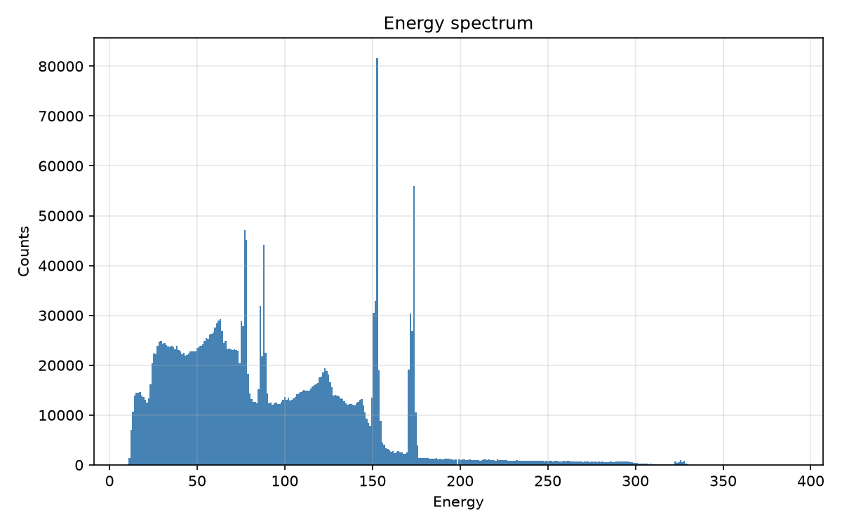  Figure 2: Energy spectrum (linear scale) | 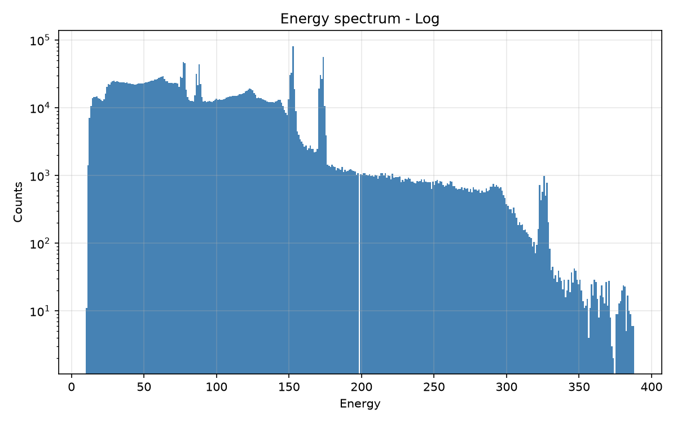  Figure 3: Energy spectrum (log scale, y-axis)

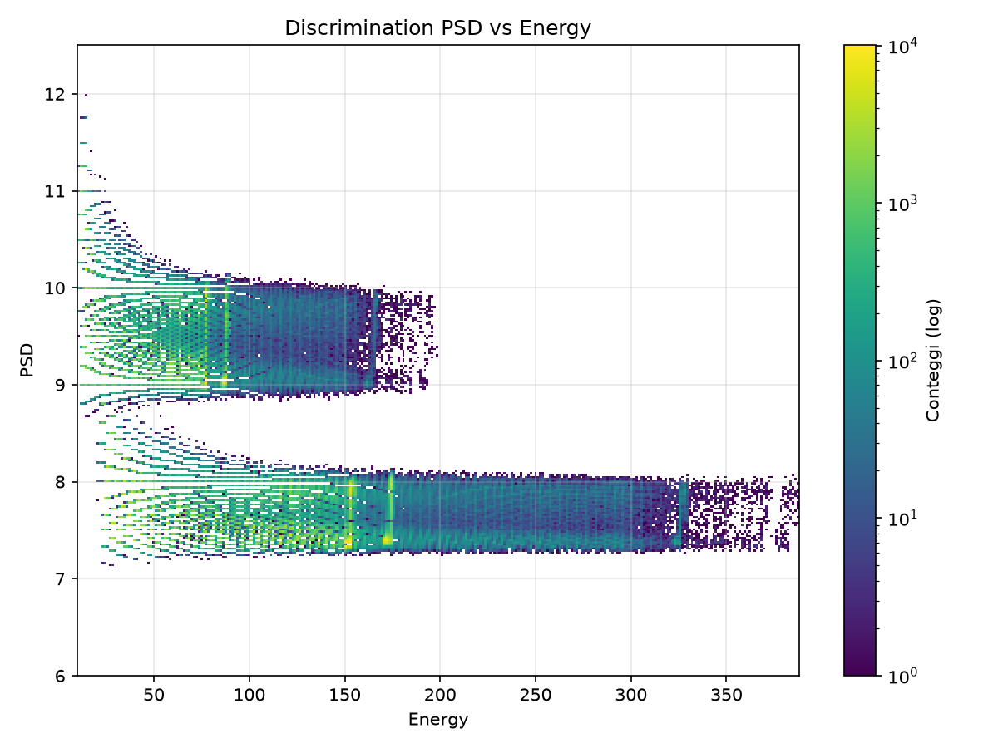
Figure 6: 2D density map (color scale = log of counts) of the PSD parameter versus energy. Two separated bands are visible.

5.. Results & Conclusion
The experiment reached its didactic goal very well. In the given time we could design and compile a complete firmware chain for PSD, based on the classic peak/Qshort technique. We checked the chain on the DT1260 digitizer, and with the Python analysis we showed that two synthetic populations, made with different tau, are correctly separated in the PSD-Energy plane. This confirms that, even if it is the simplest PSD technique, the peak/area ratio works well enough to be used in almost all real applications, especially together with a double charge integration.

Signature
Antonio Messina, INFN, Italia

